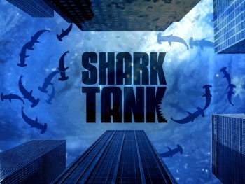
Geo-Environmental Shark Tank
Over the course of the last few days we have examined different types of energy in class, from non-renewable fossil fuels to renewable sources. While fossil fuels still power the vast majority of our energy needs, our dependency on them is dangerous; they damage our environment and they are quickly diminishing as our population increases. As a group, your job is help solve this problem by inventing a product that harnesses the power of renewable energy.
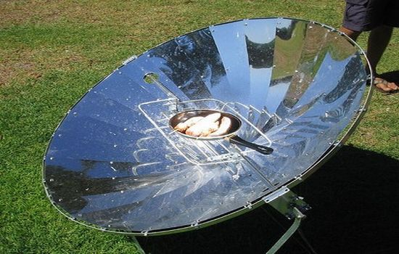
Your invention can be as small as a backyard solar-cooker, or as a big as a mass transit system—as long as it accomplishes the goal of the project: Making the world less dependent on fossil fuels such as oil, coal, and natural gas. Not only will you design this product, but you will also create a marketing campaign to help sell your invention to the public. At the end of the process, you will present your product to the class in the hopes that they will invest in your ideas.

Your group must complete the following components to receive full credit for this project:
- Name for your product: Try to make it catchy, easy to remember, and meaningful!
- Visual representation of your product: a sketch, a computer generated image, or a model/prototype
- Description of product: 2 paragraphs about your product, word processed
  - Paragraph 1 (informative) - What is your product and how is it used?
  - Paragraph 2 (persuasive) - How will it change the world and why should people buy/invest in it?
- Sales Poster: a name, slogan, price (if applicable), and catchy visuals that make people want to buy/invest
- Presentation: every team must spend 3-5 minutes presenting their product for the class in order to persuade the audience that their product is the best. This can be done 2 different ways:
  - In-class presentation (PowerPoint, Prezi, poster, skit, demonstration, etc.)
  - Pre-recorded video (commercial, advertisement, infomercial, etc.)
*Remember, your goal is to persuade your classmates to buy/invest in your product, so be sure to put together a compelling and interactive presentation… there will only be 1 winner and that winner will receive an epic prize!

You will be graded on the following components:
Product: Were all components of the project complete? 10 points
Accuracy: Did you demonstrate knowledge of renewable and non-renewable energy sources? 10 points
Classwork: Did you work productively in class? 10 points
Creativity: Was your idea original and innovative? 10 points
Presentation: Did you convey a clear and persuasive message about your product? 10 points
Group work: Did you complete an equal amount of work as your teammates? 10 points
(Each partner will receive an individual grade for this based on a group survey… do your part!)
Total: 60 points
Product Scoring Guide
Directions: As teams present, use a 1-10 scale to rate their product (1=very weak, 10=amazing!)

Product Name | Uses  Does the product have real world applications? | Marketing  Is the product well marketed and would people buy it? | Impact  Would this product change the way the world uses fossil fuels? | Overall Score:  (out of 30)

