South America: Human geography
By National Geographic Society, adapted by Newsela staff

South America extends from the Isthmus of Panama to the Tierra del Fuego archipelago in the south. It is the world's fourth largest continent.
South America and North America are named after Italian navigator Amerigo Vespucci. He was the first European to realize that the Americas were not part of the East Indies and its own separate landmass.
Today, South America is divided into many countries and territories. They include Colombia, Venezuela, Guyana, Suriname, French Guiana, Brazil, Uruguay and Argentina, Chile, Peru, Ecuador, Bolivia and Paraguay. The continent also includes several islands: the Galapagos Islands are part of Ecuador and Easter Island is part of Chile. The Falkland Islands are part of the United Kingdom, but Argentina also claims these islands.
South America’s culture is deeply influenced by indigenous people and their connection to their environment.
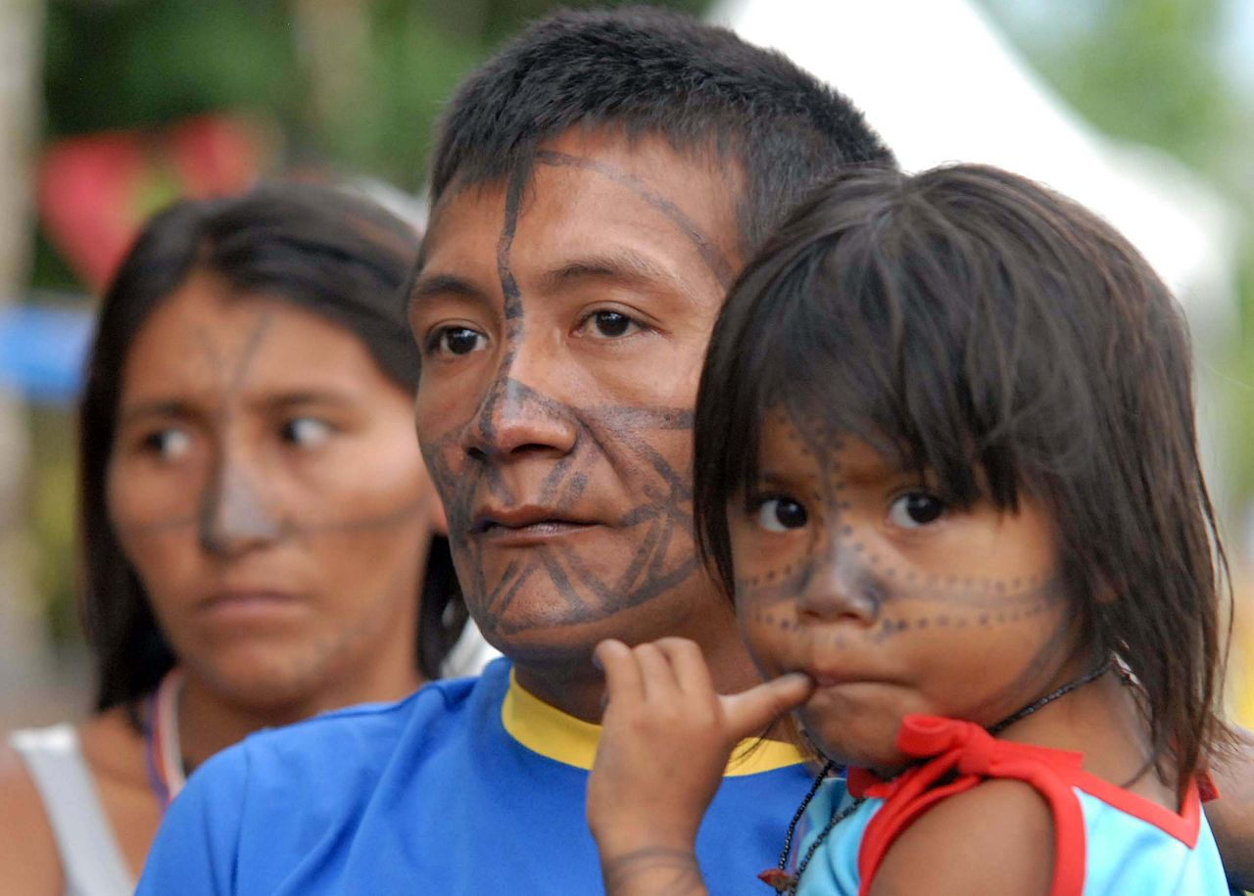Indigenous communities are located across the continent of South America. Here, people from the Tucuxi tribe in Brazil prepare to participate in a social forum. Photo: Fábio Rodrigues Pozzebom/Wikimedia.
Indigenous peoples are the descendants of those who lived on the continent before European explorers and settlers arrived. The first human populations of South America probably either arrived from Asia into North America via the Bering Land Bridge, and migrated southwards or alternatively from Polynesia across the Pacific.
Today, at least 22 million people in South America belong to an indigenous group. They speak several hundred languages. In Brazil alone, for instance, 135 languages have been confirmed.

Cultural Geography: Historic Cultures
The cultures of South America developed in three main geographical regions. They are the Pacific coast, the major rivers of the Amazon basin, and the Andes mountains.
The Inca Empire is the most well-known indigenous culture of South America. The Inca Empire was established in 1438 in Cuzco, Peru. The city is high in the Andes. The empire expanded to include parts of present-day Peru, Bolivia, Ecuador, Chile, Argentina and Colombia.
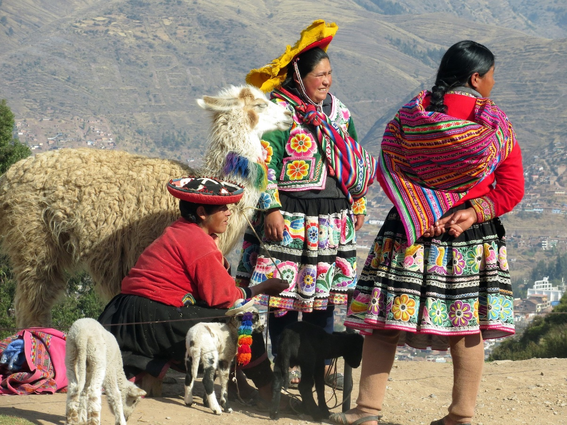
Quechua women near Cuzco, Peru. Cuzco is where the Incan Empire was established in 1438.
To communicate across this vast region, the Inca built an expansive network of roads. It was made up of two main north-south roads. One ran along the Pacific coast and another through the Andes.
Colonization of the continent by Spain and Portugal left a lasting legacy. The importation of African slaves represented a major shift in the cultural landscape of South America. Most slaves were brought to Brazil. Their culture integrated indigenous beliefs and European rituals.
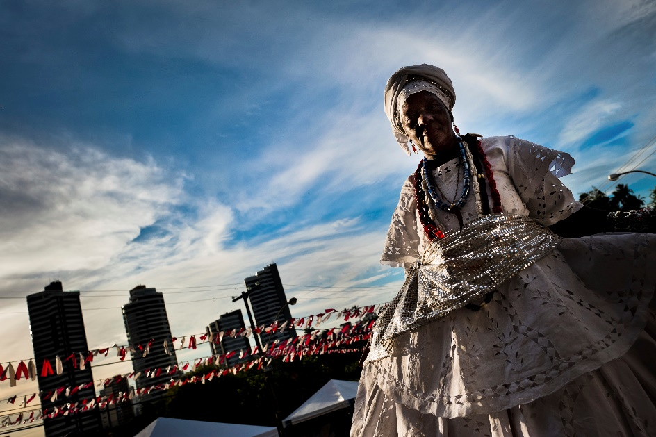
A woman before the dance in honor of Omolú. This spirit is from the African Candomblé religion. Omolú is also treated as Saint Lazarus, from the Catholic religion. In Brazil, African and Catholic religions have been mixed. Photo: Jan Sochor/Latincontent/Getty Images.
Slave owners and church leaders put slaves under intense pressure to convert to Catholicism. Over time, some slave religions added parts of Christianity, like crosses and saints.
Other historic cultures of South America developed. A gaucho, or “cowboy," culture developed in the Pampas, for instance. The Pampas are an extensive region of grasslands, located in Argentina, Brazil and Uruguay. Much like the North American cowboy, the gaucho was idealized as free-spirited, strong and honest.

Contemporary Cultures
Indigenous societies continue to have a strong presence in South America.
Religion remains the backbone of many South American cultures. Catholicism dominates the continent. Other spiritual beliefs have influenced both spiritual and secular activities.
Carnival at Sambadrome Marquês de Sapucaí in Rio de Janeiro, Brazil, 2014. Photo: Nicolas de Camaret/Wikimedia.
The Carnival of Rio de Janeiro, Brazil, is a Christian festival held every year about 40 days before Easter. It is also a huge party and attracts millions of Brazilian and foreign tourists.

Political Geography
Political geography is the relationship between governments and citizens. South America’s history and development have been shaped by its political geography.
The Treaty of Tordesillas of 1494 granted Spain and Portugal the right to colonize all lands outside of Europe. Spain colonized most of South America and Portugal colonized present-day Brazil.
The dominance of the Spanish and Portuguese languages on the continent can be attributed to Catholic missionaries, who taught them to the native peoples. The missionaries also developed writing systems for indigenous languages such as Quechua, Nahuatl and Guarani. Marriages between European colonizers and native populations established the mestizo class. Mestizos are people of mixed indigenous and European ancestry.
The successful Cuban revolution of 1959 brought communism to Cuba. Communism is a political system in which the government owns all property and people have few freedoms. The United States and other western nations feared that communism would spread throughout Latin America. Communist leaders did gain some power in South America during the 1960s. Hoping to destroy them, the United States helped overthrow the governments of Argentina, Brazil, Chile, Paraguay and Uruguay.
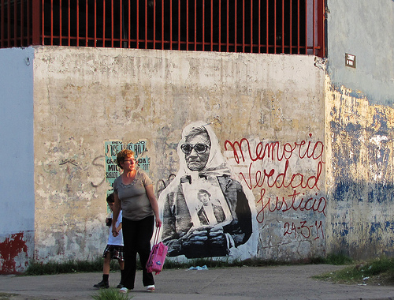
During Argentina's military dictatorship, a period also known as the Dirty War, from 1976-1983, about 30,000 people disappeared. A movement called the 'Mothers of Plaza de Mayo' began, where the mothers of disappeared people protested against the dictatorship in public. Here, a woman walks past a street mural honoring the mothers. Photo: Wikimedia
Dictatorships replaced the communist governments. They arrested tens of thousands of political prisoners, and killed many of them.

Contemporary Issues
Today, South America is trying to reduce the influence of other countries.
Nationalization is a type of ownership where the state controls an industry. Some South American nations have nationalized industries like electricity or oil.
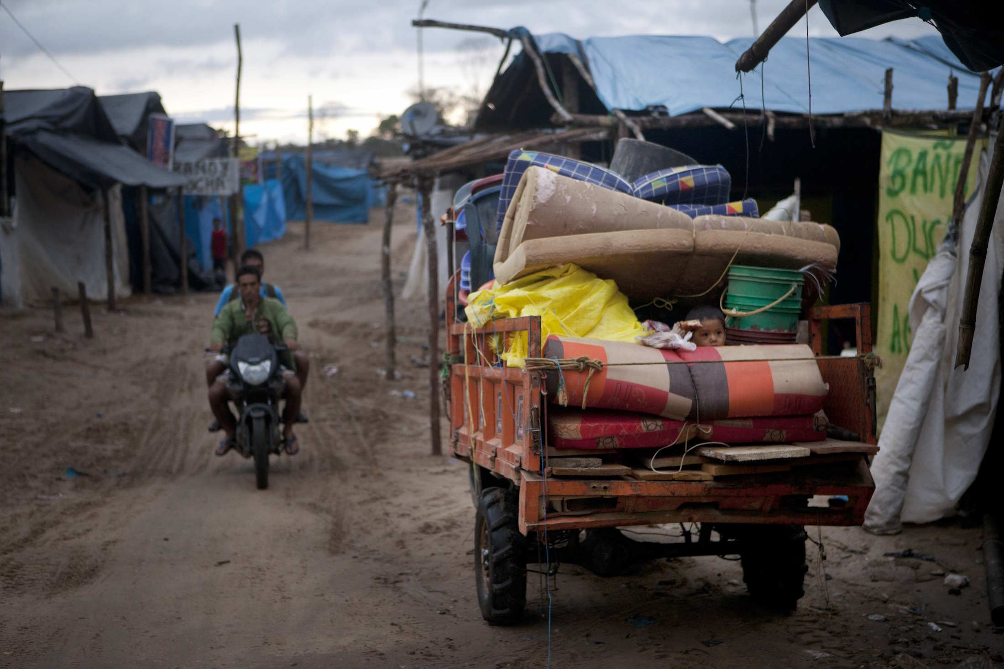
A little boy sits among his family's belongings packed in the back of a vehicle as he waits for his parents to leave the mining camp in anticipation of a government crackdown in La Pampa in the Madre de Dios region in Peru, Friday, May 2, 2014. Some people at the illegal gold mine worked up to the last minute while they feared authorities would arrive any moment as part of a government crackdown on illegal gold mining since a nationwide ban on illegal mining took effect April 19, 2014. Photo: AP Photo/Rodrigo Abd.
Many believe that nationalization has improved the lives of local people. The poor strongly support it. Others argue that nationalization has made services worse and given too much control to the government.
Some South American countries have done the opposite of nationalization. They have privatized industries. In these countries, such as Brazil and Argentina, the government has sold industries to private companies. Privatization has had mixed results. Many industries produce more goods. Services such as water and sewage are also more reliable. However, more people are unemployed, and privatization has led to higher prices.
Indigenous populations of South America have continued fighting for basic rights, such as the right to live on ancestral lands. In 2009, Bolivia passed an important new constitution. It guaranteed that indigenous groups would have more seats in the national legislature.

Future Issues
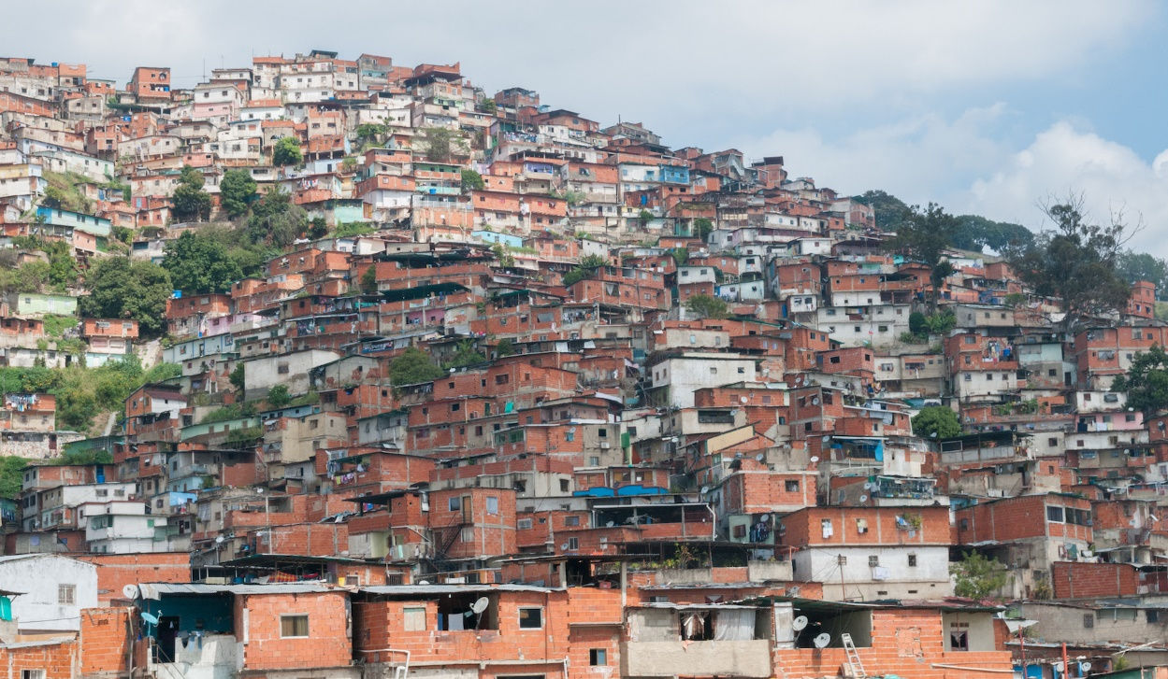
South America is home to cities that are growing larger and larger as people migrate from the countryside. In many cities, poorer residents are crowded in slums, like the Petare slum in Caracas, Venezuela. Photo: Wikimedia.
In general, the countries in South America are considered to be part of the developing world. These are countries with lower levels of income, health care and education than "developed" countries like the United States or Japan. They also tend to have a smallermiddle class. There is no agreed-upon definition of what makes a country a "developed" or "developing" country.
As a result, some people might say that the wealthier countries in South America like Argentina and Chile are developed countries, while others might not. Regardless, Latin America, which includes South America and Central America, is the most urbanized of the world’s developing regions. It is the only developing region with more poor people in cities than in rural areas.
This has put a lot of pressure on major cities in South America. Housing, crime and transportation problems are just a few of the challenges cities are facing. Many cities in South America have huge slums. These are extremely crowded areas whose residents tend to live in extreme poverty. Living conditions in slums are often unsafe — homes may not be very sturdy and services like electricity, water and sewage may not be reliable.
Rapid urbanization is destroying the unique environments of South America. The Amazon rainforest is being burned at a rate of one acre every second. Trees are harvested for the timber industry, while the plains of the rainforest are turned into ranches, farms and towns. Air and water pollution are becoming bigger problems.
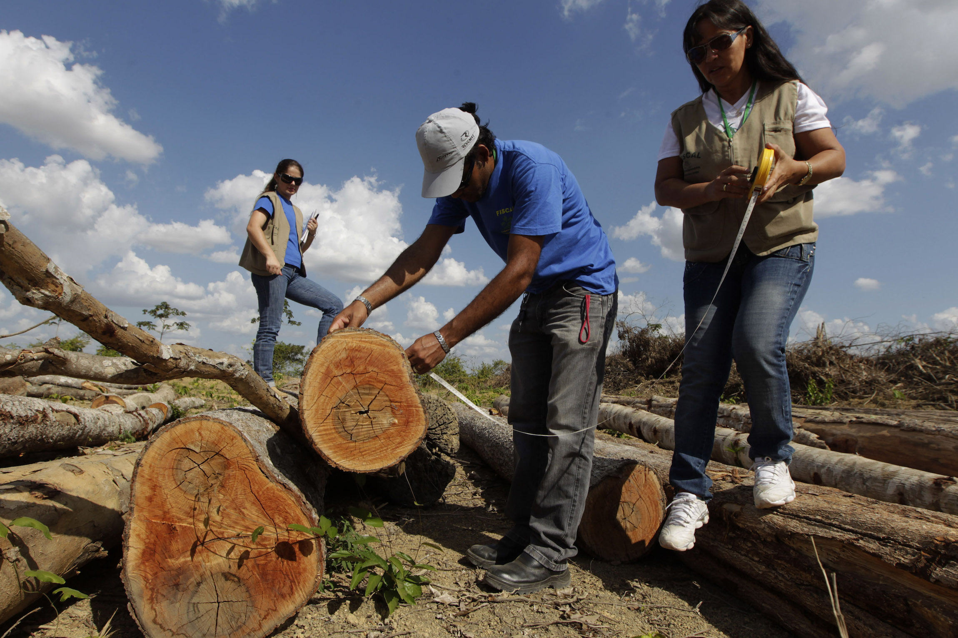In this photo taken on Sept. 22, 2011, local environmental enforcement officers measure illegally cut timber in Paragominas in the northern state of Para, Brazil. Paragominas has become a pioneering 'Green City,' a model of sustainability with a new economic approach that has seen illegal deforestation virtually halted. Photo: AP Photo/Andre Penner.
In rural areas, less money is spent on education, health care, and housing. Some of the continent’s poorest communities are indigenous populations in the mountains of Bolivia, Peru and Ecuador.
Another important factor is climate change.
The earth is warming up. Reducing carbon emissions is the most important way to reduce global warming. Carbon emissions comes from burning fossil fuels, like coal and oil. As part of an international agreement, Brazil agreed to reduce emissions by more than a third by 2025.

