Environmental Science and World Geography
Warm Ups Journal
1. Air and water are examples of ____________ in an ecosystem?
2. Renewable energy is energy from sources that

3. Which regions make up Latin America?
4. 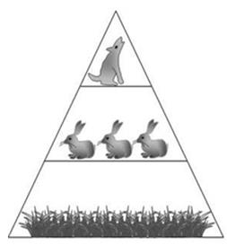
The level occupied by the wolf at the top of this energy pyramid is
5. 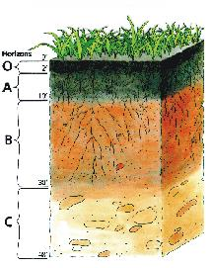
Use the soil profile to answer the following questions:
How would the density of Horizon-A & Horizon-C compare?

6. The life expectancy in sub-Saharan Africa has declined due to the epidemic of
7. 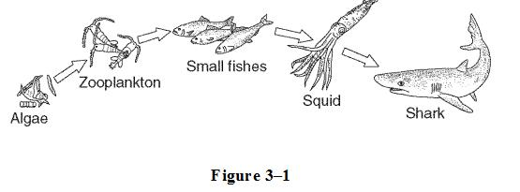
If the algae makes 1000 units of energy, how much energy is passed on to the zooplankton?
8. The Earth's surface water is found in ____________.
9. What country controls the Suez Canal and why is it important to the U.S.A.?
10. Which of the following is the BEST reason why the region is called Latin America?
11. Why are the Arabs (Palestinians) and Jews fighting in Israel?
12. The system of racial oppression that subjugated the black population of South Africa was called _____________________.
13. The religion of South Asia that has a strict social hierarchy called the caste system is _________________________.
14. The long-term weather conditions and averages for a particular area can be described as ________________________
15. What major landform has kept North African civilizations tied to the North African coast? ________________________
16. Farmland that can be used to grow crops. ______________________
17. Countries that are most likely to suffer from water stress would be located _________.
18. The longest river in Europe is the:__________________________
19. The most energy efficient vehicles available today are
20. The ozone layer helps reduce the amount of __________________ that reaches the Earth's surface.
21. Why does the United States seek to influence countries such as Saudi Arabia, Kuwait, & Iraq?
22. Animals that live in estuaries ____________.
23. The world's largest mountain, Mt. Everest, is found in which mountain chain in South Asia? ________________________________________
24. The relationships between a Canadian lynx (large cat) and a snowshoe hare (rodent) is an example of: ____________________________________________
25. Which of the following is considered the fastest growing source of energy in the world?_____________________________
26. Which layer of the atmosphere is closest to the surface of the Earth and is where weather happens? ____________________________________
27. Which European nation has voted to withdraw from the European Union?
28. The effects of water pollution on ecosystems _________________.
29. What is the name of the stateless nation that is in conflict with the Jewish state of Israel? ____________________________________
30. What term is used to refer to the many feeding relationships that are possible in an ecosystem?
31. Nonrenewable energy resources formed from the remains of organisms that lived long ago. _____________________________________-
32. Which statement describes how humans are affecting the balance of carbon in the atmosphere?
33. The _____________________________ River, located in South Asia, is sacred to the Hindu faith.
34. Wind, moving water, sunlight, and heat from Earth's interior are sources of
35. The increase in greenhouse gases could result in which of the following?
36. Cutting trees, brush and grasses and burning the debris to clean the fields and cause exhaustion of the soil is what type of farming?
37. Bacteria can kill organisms in eutrophic lakes by _______________.
38. Which organism is likely to be in the bottom trophic level in a food chain?
39. In which layer of the atmosphere is the Ozone Layer contained?
40. One benefit of guerilla gardening is...
41. Which of the following best describes why many people in the world go hungry?
42. What is the dominant climate found in the Amazon River Valley?
43. What causes food deserts in urban areas?
44. Geothermal heat pumps can heat homes by
45. This man-made chemical; that used to be found in many household aerosol sprays, is believed to damage the ozone layer.
46. Who mines the resources and takes the profits in much of Africa?

47. The man who arranged the Berlin Conference to divide Africa into colonies to be shared among European nations was _____________________ of Belgium
48. What is the major climate of Southern Europe?
49. When neighborhood residents noticed a large number of dead fish in a local creek, they traced the problem to a nearby gas station. It turned out that a tank of gasoline developed a leak. This an example of
50. Which form of energy involves radio active waste as a by product?

