Africa's rich human geography
By National Geographic Society, adapted by Newsela staff

Africa is the world's second-largest continent. It is bounded by the Mediterranean Sea, the Red Sea, the Indian Ocean and the Atlantic Ocean.
Today, Africa is home to more countries than any other continent. It is also home to many different peoples, each with their own culture and language.

Major Cultural Groups
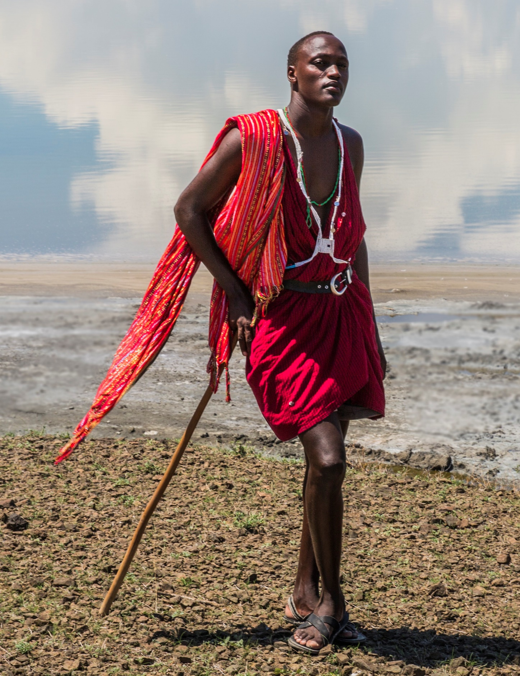Maasai Warrior in Magadi, Kenya. Photo: Ninaras/WIkimedia. [click to enlarge]
Today, there are hundreds of native languages and cultures in Africa. Most of these groups mix traditional customs and beliefs with modern social practices and conveniences. Three groups that demonstrate this are the Maasai, Tuareg and Bambuti.
Maasai peoples are the original settlers of southern Kenya and northern Tanzania. The Maasai are nomadic pastoralists. Nomadic pastoralists are people who are always on the move to find fresh grasslands or pastures for their livestock. The Maasai travel throughout East Africa and survive off the meat, blood and milk of their cattle.
The Maasai are famous for their striking red robes and rich traditional culture. Young Maasai men between the ages of 15 and 30 are known as moran, or "warriors." Yet, even though some remain nomadic, many Maasai have begun to integrate themselves into the societies of Kenya and Tanzania.
Another pastoralist group are the Tuareg in North and West Africa. The harsh climate of the Sahara and the Sahel has influenced Tuareg culture for centuries. The Tuareg traditionally wear head wraps. called cheches, which protect them from the Saharan sun. Light, sturdy gowns called bubus allow for cool airflow while deflecting heat and sand. Tuaregs are often called the "blue men of the Sahara" for the blue-colored bubus they wear in the presence of women, strangers and in-laws.
A third major group are the Bambuti, which include four populations in Central Africa: the Sua, Aka, Efe and Mbuti. The Bambuti live primarily in the Congo Basin and Ituri Forest. Sometimes, these groups are called "pygmies," although the term is often considered offensive. Pygmy is a term used to describe various ethnic groups who are usually less than 5 feet tall.
The Bambuti have been living in the same area for 4,500 years. Their ancestors were likely some of the first modern humans to migrate out of Africa.

The "Cradle Of Humankind"
The African continent is widely believed to be the "cradle of humankind." Most scientists believe human beings first appeared in Africa, then spread to the rest of the world. This human movement, or migration, plays a key role in Africa and the world's history. It began tens of thousands of years ago.
Two other major migrations helped shape Africa. These are the Bantu Migration and the African slave trade.

The Huge Bantu Migration
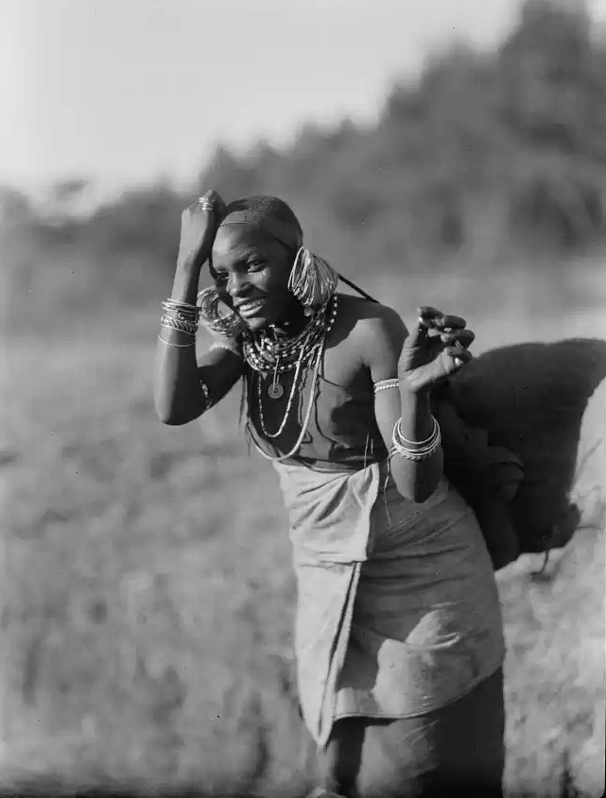
A Kikuyu woman in 1930. The Kikuyu are the main inhabitants of Kenya, and are members of the Bantu language group. Photo: Mukuyu/National Archives. [click to enlarge]
The Bantu Migration was a huge migration of people across Africa. It began about 2,000 years ago, and lasted for 1,500 years. The migrants were a people whose language belonged to the Kongo-Niger language group. "Bantu" is a common Kongo-Niger word for human being.
Historians do not know why the Bantu moved away from their homes near the Niger river in West Africa. They first moved southeast, through the rain forests of Central Africa. Eventually, they migrated to the southern parts of the continent.
Bantu migrants introduced many new skills into the areas they entered. These skills included growing crops and forging tools and weapons from metal. Such skills allowed Africans to cultivate many new regions. Many hunter-gatherer communities were absorbed into the more technologically advanced Bantu culture.
Today, much of the African population is at least partly descended from these Bantu migrants. This is especially true in East, Central and Southern Africa.

The Slave Trade
The third major human migration in Africa was caused by the slave trade.
Between the 1400s and 1800s, European slave traders forced more than 15 million Africans into slavery. These slaves were transported across the Atlantic Ocean to be sold in North and South America. Millions of slaves were also transported within the continent. Most were taken from Central Africa and Madagascar. They were then brought to North Africa and the European colony of South Africa.
Millions of Africans died in the slave trade. Thousands died during the forced migration to trading centers, and even more lost their lives during the dangerous voyage across the Atlantic Ocean. Altogether, slavery may have cut Africa's population growth in half.

The Great West African Kingdoms
Before the slave trade, western Africa had seen the rise and fall of three great kingdoms between 800 and the 1500s. The first was the Kingdom of Ghana, which became a powerful empire through its gold trade. The Ghanaian trade routes spread far and wide, into the rest of Africa and as far as Europe. Ghanaian kings controlled the region for about 400 years.
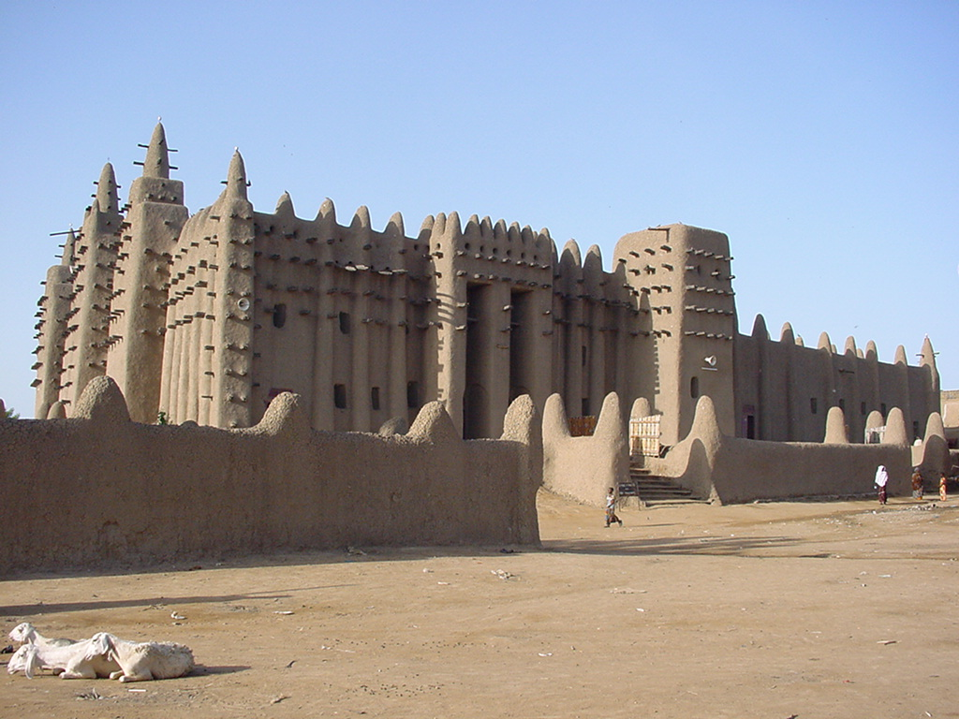
The Great Mosque of Djenné, in Mali. During the Middle Ages, Djenné was not only an important trading site but also a center of scholarship and Islamic practice. Photo: Andy Gilham/Wikimedia. [click to enlarge]
Next came the Kingdom of Mali, which took over and continued the Kingdom of Ghana's gold trade. In addition, it developed a profitable trade in salt and copper. The Kingdom of Mali's great wealth allowed it to develop important learning centers that drew scholars from around the world. In particular, Mali became a center for Islam, one of the great world religions along with Christianity, Buddhism and Hinduism.
The Kingdom of Songhai took over the Kingdom of Mali, and expanded even further. Songhai kings expanded trade routes, set up a new system of laws, expanded the military and encouraged scholarship.

Colonization And Problems Today
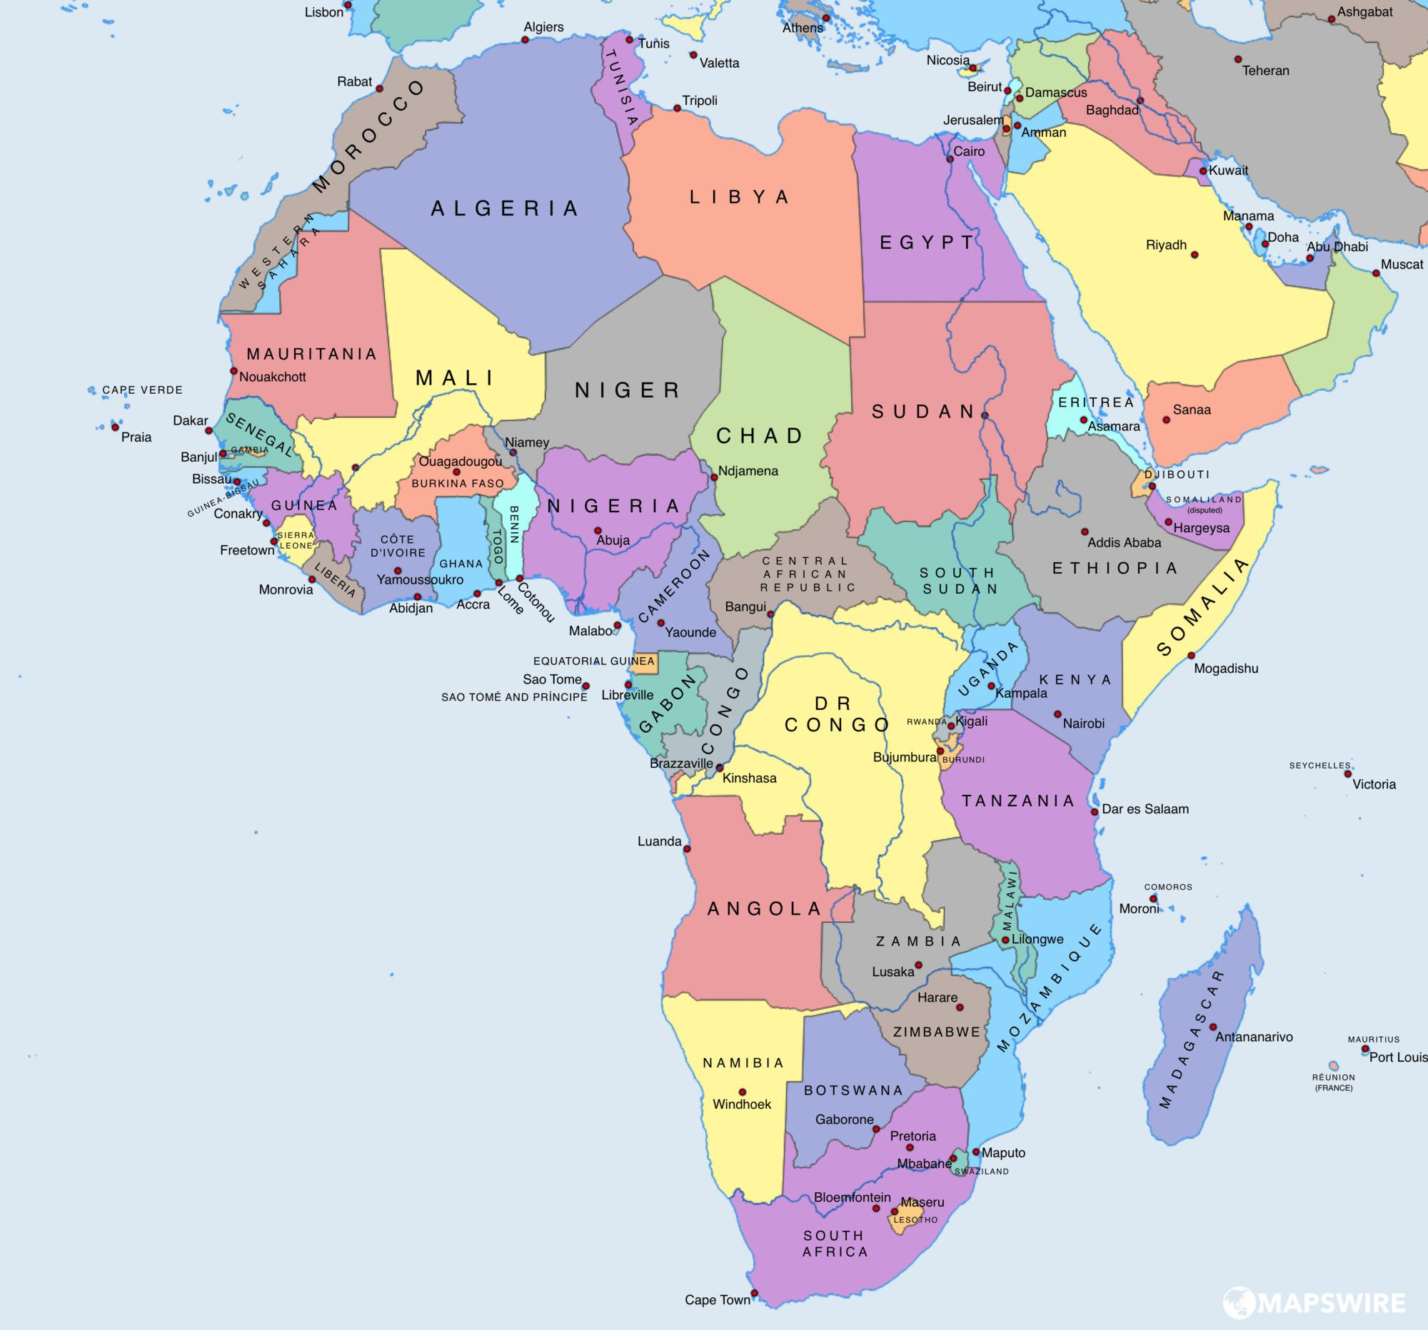A political map showing all African countries today. Map: Robinson/Mapswire. [click to enlarge]
Colonization by Western powers dramatically changed Africa. From the 1880s to the 1900s, almost all of Africa was exploited and colonized. European powers saw Africa as a source of raw materials and a market for manufactured goods. The European colonizers included Britain, France, Germany, Belgium and Italy.
The effects of colonialism haunt Africa today. Natural resources, including diamonds and gold, were overexploited. European business owners became wealthy from trade in these natural resources, while their African workers labored in poor conditions for little pay.
European powers drew new political borders that divided established governments and cultural groups. These new boundaries also forced different cultural groups to live together, which led to tensions and conflicts that last to this day.
After World War II (1939–1945), Africans quickly rose up against colonial rule. By 1966, all but six African countries were independent nation-states.
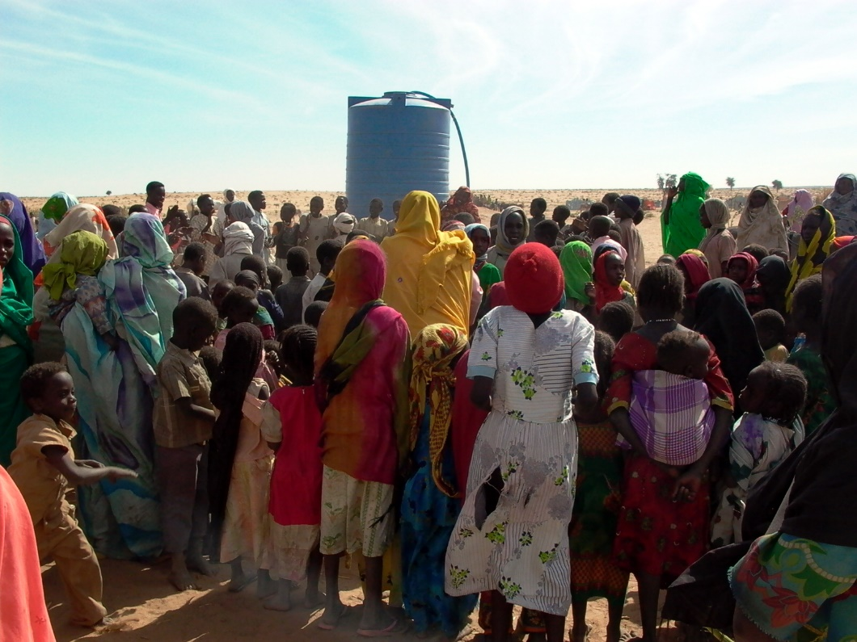
Refugees near a water tank in Genenia, West Darfur in 2007. Photo: Nite Owl/Wikimedia. [click to enlarge]
However, many parts of Africa still face poverty, hunger and lack of medical resources. Another problem is global warming, which is the warming of the planet due to gases from cars and factories. In many parts of Africa, and the world, global warming is making it harder and harder to survive. Many communities in Africa are forced to relocate and become refugees in other countries.
Africa will need foreign assistance in order to react against climate change. For this to become a reality, leaders within and outside of Africa will need to seek greater international cooperation.

